
Create ci pipeline that will deploy and configure these VMs using terraform and ansible according following requirements
- Deploy 2 virtual machines using terraform.
  - first vm on Amazon linux, hostname: c8.local
  - second vm on ubuntu 21.04, hostname: u21.local
- As a result of terraform execution, dynamically create inventory for ansible
  - c8.local should be in the frontend group
  - u21.local should be in the backend group
- Create ansible playbook for c8.local and u21.local
- for linux OS playbook should apply the following changes
  - selinux: disable
  - firewalld: disable
- for frontend playbook group should install and configure nginx
  - nginx configuration should do proxying from port 80 on port 19999 to the
  - backend group
- for the backend group, the playbook must install the Netdata application from the
  - official repositories and run it on port 19999.

1. Objective
The goal is to architect and deploy a high-availability Nginx Reverse Proxy on AWS using Infrastructure as Code (Terraform) and Configuration Management (Ansible). The infrastructure consists of a frontend Amazon Linux VM serving as a gateway to an Ubuntu backend VM running Netdata for real-time monitoring.
Prerequisites Checklist
- Jenkins Server : The Jenkins server must have Terraform (v1.0.0+) and Ansible (core 2.15.3+) installed.
- AWS Infrastructure Access: An active AWS account with IAM permissions to create EC2 instances and Security Groups is required.
- IAM Credentials: AWS Access Key ID and Secret Access Key must be stored in the Jenkins Credential Manager with the ID aws-keys.
- SSH Key Management: A private key file (e.g., sshless.pem) must be uploaded to Jenkins as a Secret file with the ID ssh-key-file to allow Ansible to authenticate with the new VMs.
- Networking Rules: The target AWS Security Group must allow inbound traffic on Port 22 (SSH), Port 80 (HTTP), and Port 19999 (Netdata communication).
- Source Control Integration: A GitHub repository (such as ansible-challange) containing the main.tf, setup.yml, and Jenkinsfile must be accessible by Jenkins.
- System Permissions: The jenkins user on the controller must have read/write permissions for the workspace directory to generate the inventory.ini and manage Terraform state files.
- Instance Images (AMIs): Valid AMI IDs for Amazon Linux 2 and Ubuntu 22.04 LTS must be specified in the Terraform code for the us-east-1 region.
2. Step-by-Step Implementation
Phase A: Infrastructure Provisioning (Terraform)
- Provider Configuration: Define the AWS region (us-east-1) and authenticate using Jenkins-stored credentials.
- Resource Creation: Deploy two EC2 instances with specific hostnames (c8.local and u21.local) and OS types (Amazon Linux and Ubuntu).
- Dynamic Inventory: Automatically generate an inventory.ini file that groups the frontend and backend nodes by their public IPs.

Phase B: Configuration Management (Ansible)
- OS Hardening: Disable SELinux and stop local firewalls to ensure seamless port communication between nodes.
- Backend Setup: Install the official Netdata monitoring agent on the Ubuntu server and configure it to listen on port 19999.
- Frontend Setup: Install Nginx on the Amazon Linux server, wipe default configurations to prevent port 80 conflicts, and deploy a custom proxy configuration.

Phase C: CI/CD Orchestration (Jenkins)
- Pipeline Scripting: Use a Jenkinsfile to pull the code from GitHub, apply the Terraform plan, and execute the Ansible playbook sequentially.
- Credential Handling: Securely inject AWS Access Keys and SSH Private Keys into the build environment using specialized Jenkins bindings.
Install Ansible on the Jenkins Server
You need to log into your Jenkins server terminal and install Ansible so the pipeline can execute the commands. Run the following:
# Update packages
sudo yum update -y # If using Amazon Linux/RHEL
# Install Ansible
sudo yum install ansible -y
# Verify installation
ansible –version

2. Verify Jenkins Permissions
Ensure the jenkins user has the rights to execute ansible. You can test this by switching to the jenkins user and checking the version:
sudo su -s /bin/bash jenkins -c "ansible --version"

3. Validation
To verify the deployment is successful, perform the following checks:
- Service Connectivity: Log into the Jenkins Controller and run ansible all -m ping -i inventory.ini to ensure all nodes are reachable.
- Configuration Check: Ensure the nginx.conf on the frontend is correctly forwarding traffic to the backend IP on port 19999.
- End-to-End Test: Access the public IP of the frontend VM via a web browser:
  - URL: http://<frontend-public-ip>.
  - Success Criteria: The Netdata dashboard should load immediately, proving the proxy is working.

4. Conclusion
This project successfully demonstrates a modern DevOps Lifecycle. By automating the deployment, we eliminated manual configuration errors, such as the Nginx port conflicts encountered during the build process. The result is a scalable, reproducible environment that combines the speed of Cloud Engineering with the monitoring visibility required for IT Management.

Step-by-Step Implementation
Install on Jenkins server
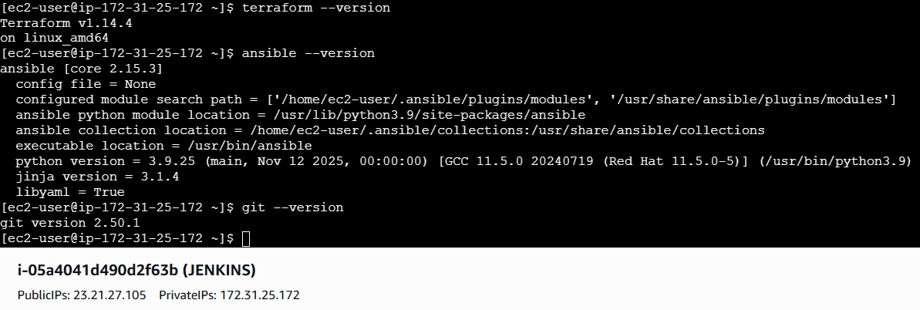

Launch your Jenkins and install aws credential plugin
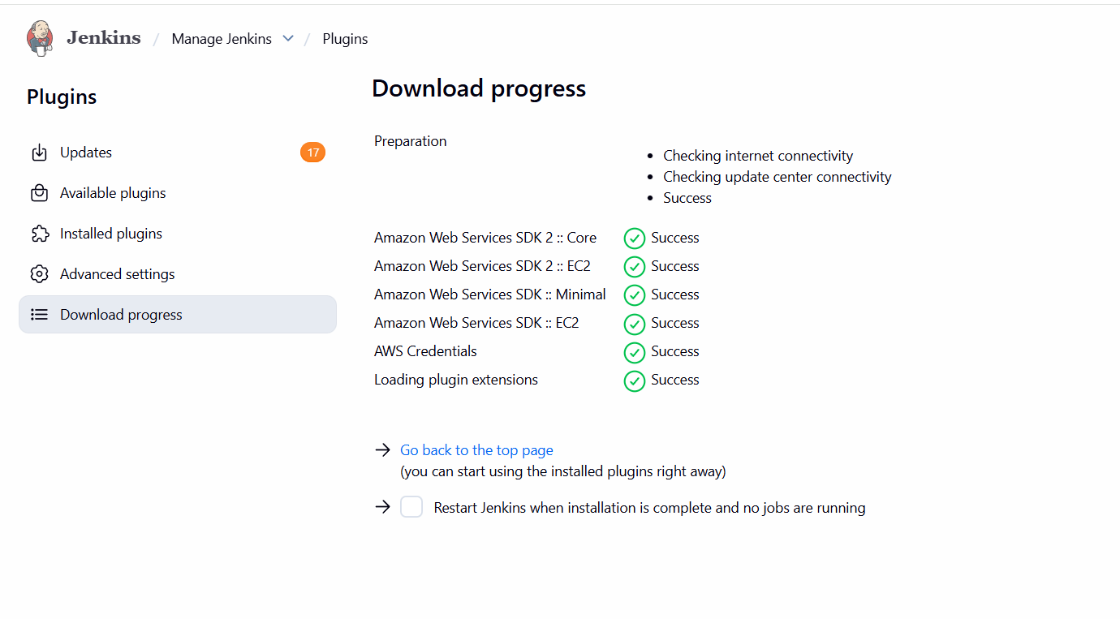

Generate access key and secret key on aws and add in Jenkins credentials
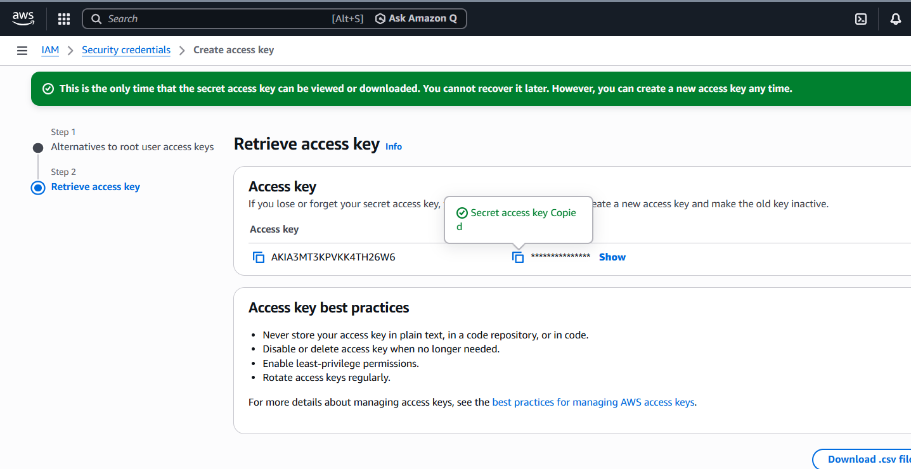

And also your ssh key to launch instances
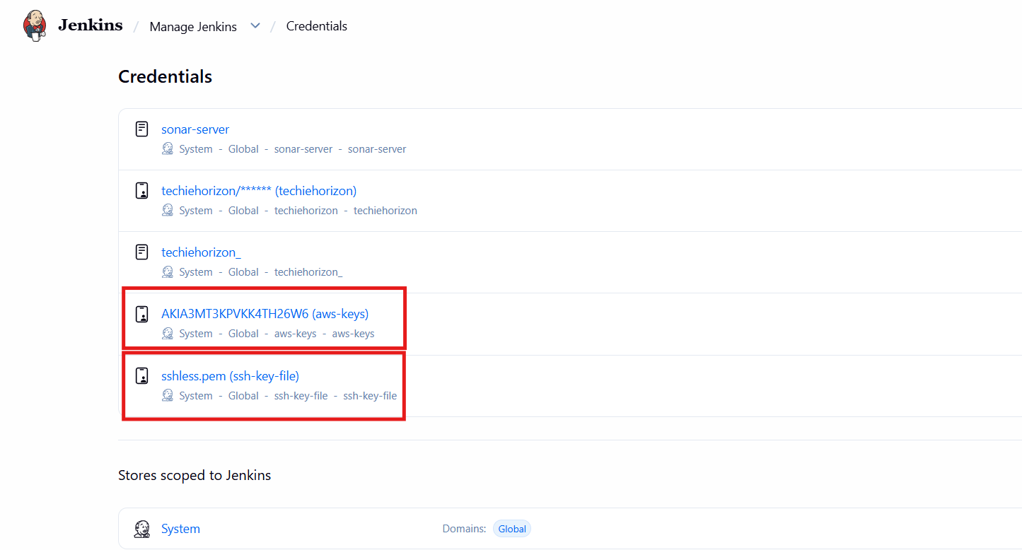
Update the security groups with 19999 port number
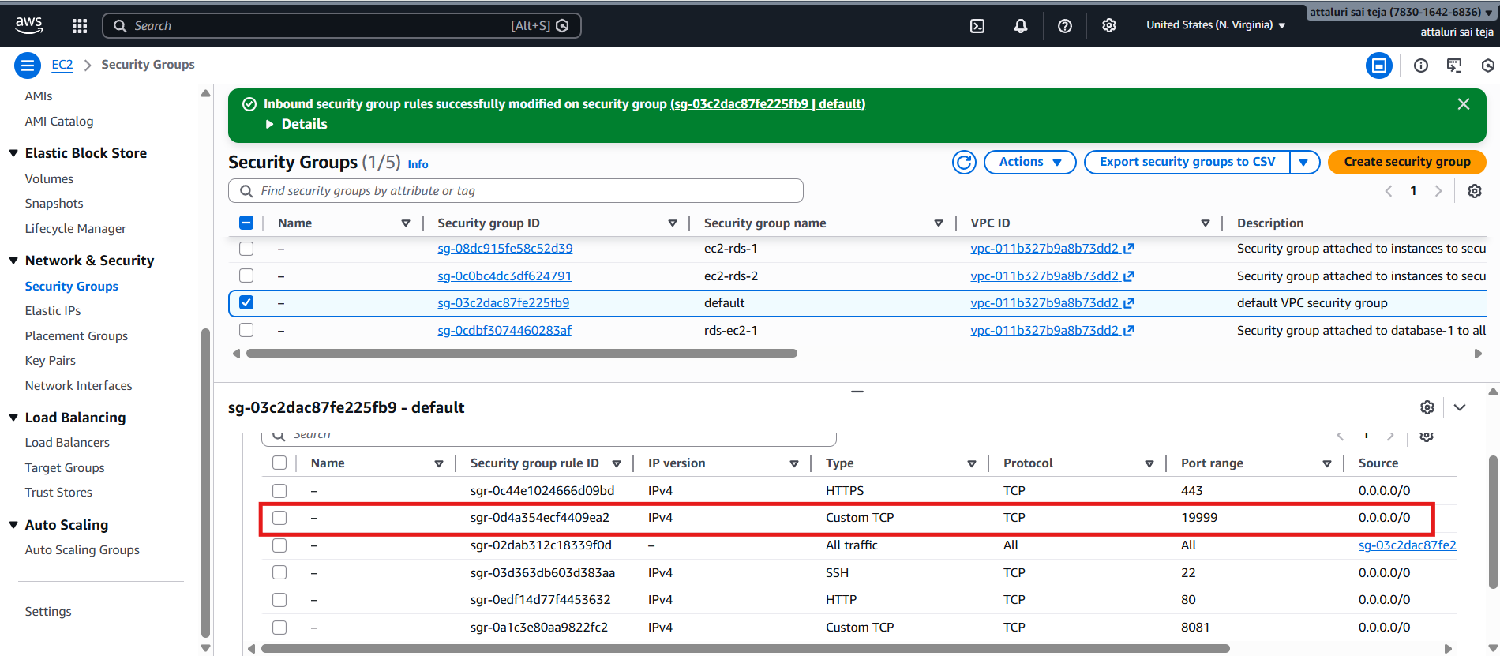

Create 3 files called main.tf , Jenkinsfile, and setup.yml file and push to git hub
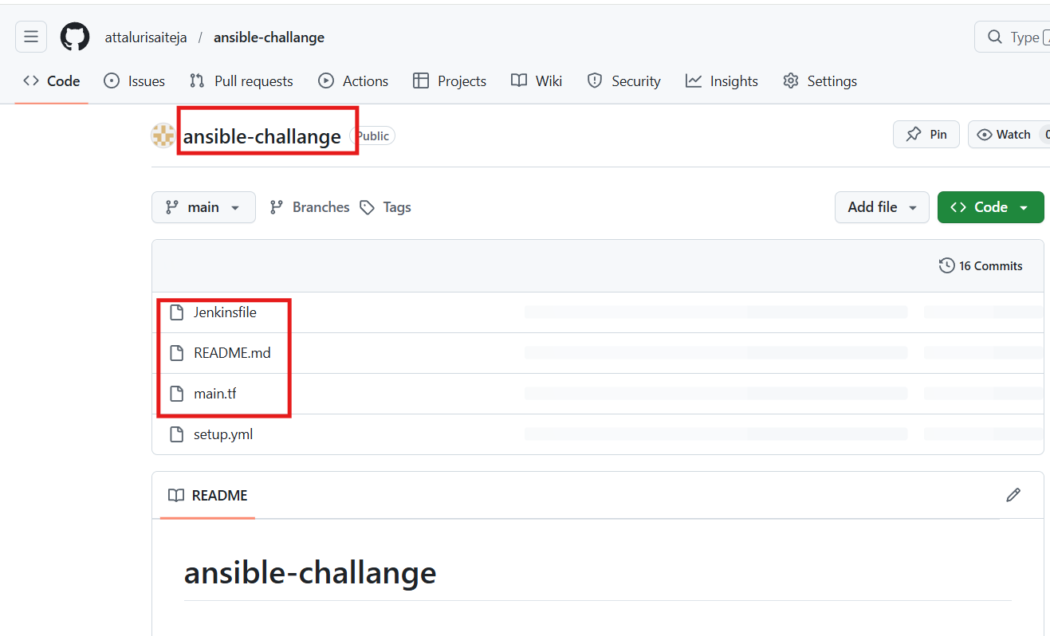
Create a pipeline based job and in definations select pipeline from scm and add the git hub link and procees to save
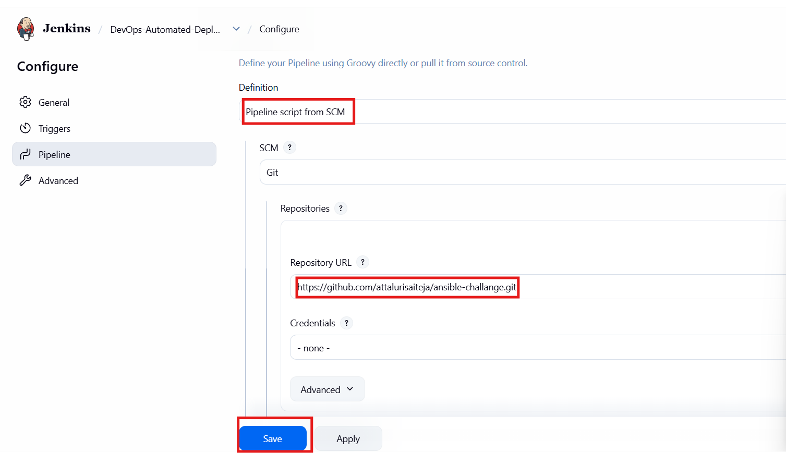

Click on build and check the output
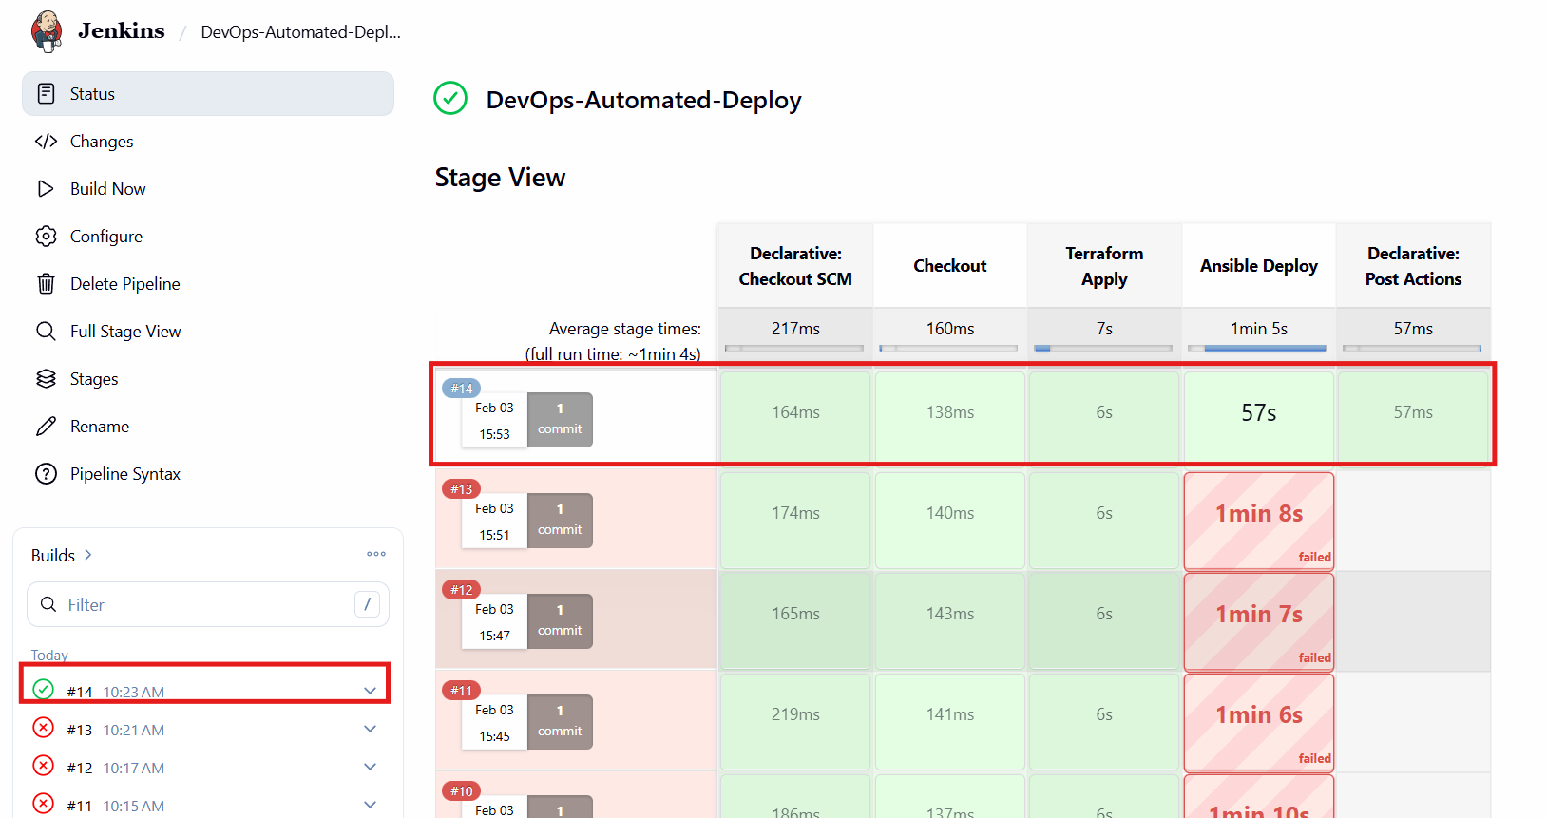
Output From frontend public ip
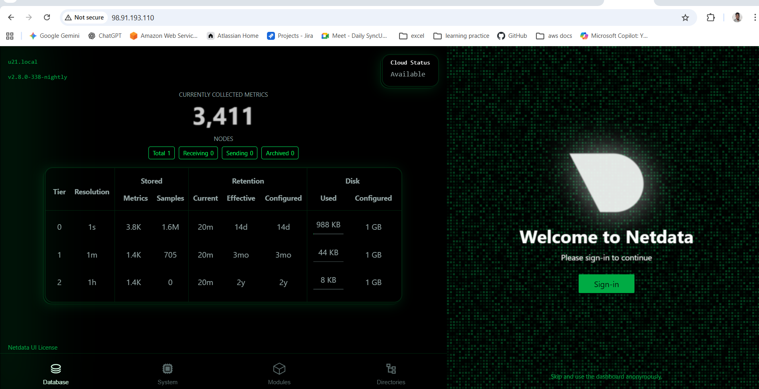

Output from backend public ip
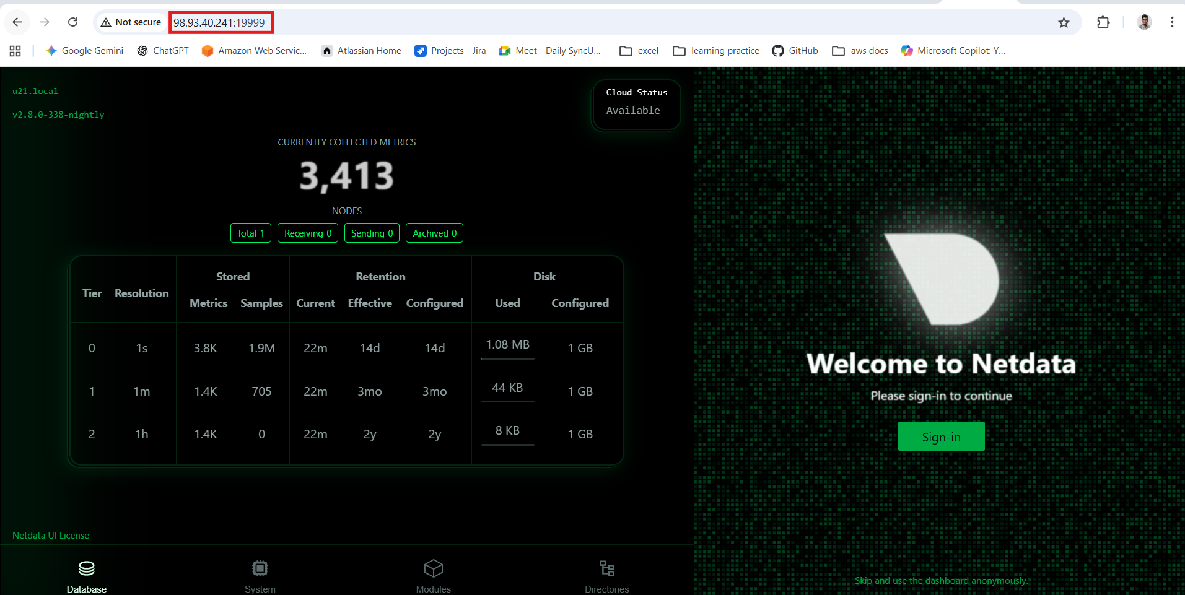
Validation of instances creation using terraform
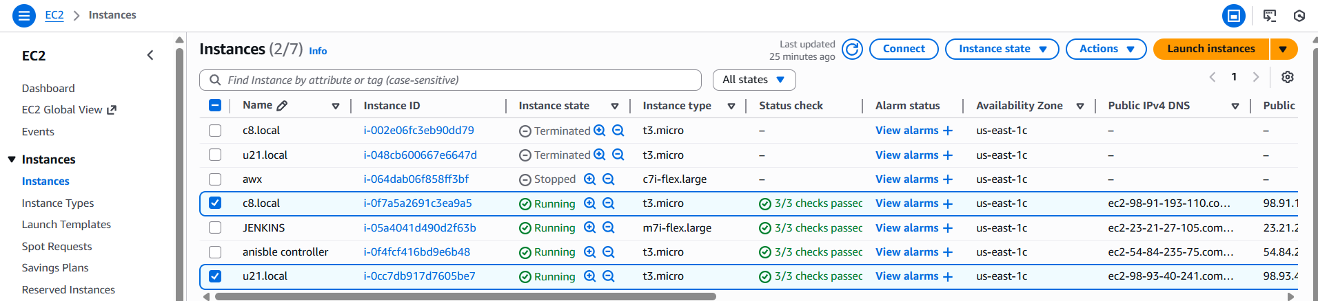
My git hub repo link :: https://github.com/attalurisaiteja/ansible-challange.git
Syntax::
Main.tf
provider "aws" {
region = "us-east-1"
}
# First VM: Amazon Linux
resource "aws_instance" "amazon_linux_vm" {
ami = "ami-0532be01f26a3de55" # Amazon Linux 2 AMI ID
instance_type = "t3.micro"
key_name = "sshless"

tags = {
Name = "c8.local"
}

user_data = <<-EOF
#!/bin/bash
hostnamectl set-hostname c8.local
EOF
}

# Second VM: Ubuntu 21.04
resource "aws_instance" "ubuntu_vm" {
ami = "ami-0b6c6ebed2801a5cb" # Ubuntu 22.04 AMI ID
instance_type = "t3.micro"
key_name = "sshless"

tags = {
Name = "u21.local"
}

user_data = <<-EOF
#!/bin/bash
hostnamectl set-hostname u21.local
EOF
}

output "frontend_ip" {
value = aws_instance.amazon_linux_vm.public_ip
}

output "backend_ip" {
value = aws_instance.ubuntu_vm.public_ip
}

resource "local_file" "ansible_inventory" {
filename = "inventory.ini"
content = <<-EOT
[frontend]
c8.local ansible_host=${aws_instance.amazon_linux_vm.public_ip} ansible_user=ec2-user

[backend]
u21.local ansible_host=${aws_instance.ubuntu_vm.public_ip} ansible_user=ubuntu
EOT
}

Syntax:: jenkins file
pipeline {
agent any
environment {
// These IDs must match exactly what you created in Jenkins
AWS_ID = 'aws-keys'
SSH_ID = 'ssh-key-file'
}
stages {
stage('Checkout') {
steps {
checkout scm
}
}
stage('Terraform Apply') {
steps {
withCredentials([aws(credentialsId: "${AWS_ID}", accessKeyVariable: 'AWS_ACCESS_KEY_ID', secretKeyVariable: 'AWS_SECRET_ACCESS_KEY')]) {
sh 'terraform init'
sh 'terraform apply -auto-approve'
}
}
}
stage('Ansible Deploy') {
steps {
echo "Waiting for instances to initialize..."
sleep 45
withCredentials([file(credentialsId: "${SSH_ID}", variable: 'SSH_KEY_PATH')]) {
sh "ansible-playbook -i inventory.ini setup.yml --private-key ${SSH_KEY_PATH} --ssh-common-args='-o StrictHostKeyChecking=no'"
}
}
}
}
post {
success {
echo "Deployment successful! Access the frontend IP on port 80."
}
}
}
Syntax::
Setup.yml
---
############################################
# OS HARDENING (ALL SERVERS)
############################################
- name: Basic OS Hardening
hosts: all
become: yes

tasks:
- name: Disable SELinux on RedHat systems
selinux:
state: disabled
when: ansible_os_family == "RedHat"

- name: Stop and disable firewall (best effort)
service:
name: firewalld
state: stopped
enabled: no
when: ansible_os_family == "RedHat"
ignore_errors: yes

- name: Stop and disable UFW (Ubuntu systems)
service:
name: ufw
state: stopped
enabled: no
when: ansible_os_family == "Debian"
ignore_errors: yes

############################################
# BACKEND SERVER (NETDATA)
############################################
- name: Setup Backend Monitoring (Netdata)
hosts: backend
become: yes

tasks:
- name: Install Netdata if not already installed
shell: |
wget -O /tmp/netdata.sh https://get.netdata.cloud/kickstart.sh
sh /tmp/netdata.sh --non-interactive
args:
creates: /usr/sbin/netdata

- name: Ensure Netdata listens on port 19999
lineinfile:
path: /etc/netdata/netdata.conf
regexp: '^\\s*default port ='
line: ' default port = 19999'
notify: Restart Netdata

handlers:
- name: Restart Netdata
service:
name: netdata
state: restarted

############################################
# FRONTEND SERVER (NGINX REVERSE PROXY)
############################################
- name: Setup Frontend Reverse Proxy (Nginx)
hosts: frontend
become: yes

vars:
backend_ip: "{{ hostvars[groups['backend'][0]].ansible_host }}"

tasks:
- name: Install Nginx
package:
name: nginx
state: present

- name: Ensure nginx configuration directory exists
file:
path: /etc/nginx/conf.d
state: directory
mode: '0755'

- name: Configure main nginx.conf
copy:
dest: /etc/nginx/nginx.conf
content: |
user nginx;
worker_processes auto;
pid /run/nginx.pid;

events {
worker_connections 1024;
}

http {
include /etc/nginx/mime.types;
default_type application/octet-stream;

access_log /var/log/nginx/access.log;
error_log /var/log/nginx/error.log warn;

sendfile on;
keepalive_timeout 65;

include /etc/nginx/conf.d/*.conf;
}

- name: Configure Nginx reverse proxy
copy:
dest: /etc/nginx/conf.d/proxy.conf
content: |
server {
listen 80 default_server;

location / {
proxy_pass http://{{ backend_ip }}:19999;
proxy_set_header Host $host;
proxy_set_header X-Real-IP $remote_addr;
proxy_set_header X-Forwarded-For $proxy_add_x_forwarded_for;
}
}

- name: Validate Nginx configuration
command: nginx -t
changed_when: false

- name: Start and enable Nginx
service:
name: nginx
state: started
enabled: yes

